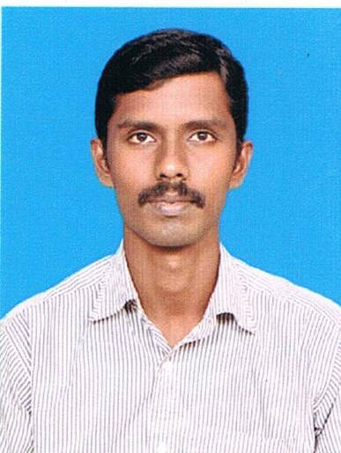SELVAM N

74/3 Arattu road,

Near S,M.R.V School,

Vadaseri,

Nagercoil,

Tamilnadu-629001.

Email: [selvamnatarajan10@gmail.com](mailto:selvamnatarajan10@gmail.com)

**Mobile: +919566150478**

**CAREER OBJECTIVE:**

To pursue a career in a dynamic and stable workplace, where I can utilize my Knowledge to solve challenges in a creative and effective manner.

**EDUCATION QUALIFICATION:**

* 2009-2012 : B.E.Automobile Engineering, Rajalakshmi Engineering College,

Anna University, Chennai (CGPA 7.09)

* 2006-2009:Diploma in automobile engineering,K.N.S.K Polytechnic college,Nagercoil,

(Aggregate 84.5%)

* 2001-2002 : ITI(Welder)Government ITI Nagercoil,
* 2000-2001 : SSLC, D.V.D Higher Secondary school,Nagercoil.State Board(74.4%)

**INDUSTRIAL VISITS:**

* Delphi TVS
* Popular motors
* Super auto Forge

**PROJECTS UNDERTAKEN:**

* Design and fabrication of Electric Two Wheeler

**EXPERIENCE:**

* One year apprentice welder in RANE ENGINE VALVES Ltd.,Chennai

**SOFTWARE SKILLS:**

* MS-OFFICE
* AutoCAD,
* Pro-E

**AREAS OF INTEREST:**

* Chassis and transmission and Manufacturing Process.

**STRENGTHS:**

* Hard working, Team Player and good leadership skills

**PERSONAL PROFILE:**

: 31-07-1986

: 26 yrs.

: Bachelor

: Male

: English,Tamil

: C.Natarajan

Date of Birth

Age

Marital Status

Gender Languages Known Father’s Name

**REFERENCE:**

* Philip Praveen, Director of Training & Placement -REC/RIT

**Authentically,**

**N.SELVAM**